学术分会场摘要投稿要求
内容要求
包括标题、作者姓名及单位、摘要正文（背景、目标和内容、研究方法、结果和讨论、结论）、关键词、主要图表。提交全英文摘要（300-500词），也可选择提交中文或英文全文。

格式要求
英文题名:
Times New Roman，小三，加粗，两端对齐，段前1行，段后0行
英文作者名：Times New Roman，小四
英文地址：Times New Roman，小五
英文摘要及关键词：
Times New Roman，五号，“abstract”, “Background, Aims and Scope.”, “Methods.”, “Results and Discussion.”, “Conclusion.”, “key words:” 加粗，关键词段前0行，段后1行
图表：
英文图题表题为小五号Times New Roman，加粗。图表中所有字母、文字字号大小应一致（一般用小五号）。
图表随正文，先见文字后见图表。
表格使用三线表，直接放在正文中适当的位置。表格应配有表序号、表题和详尽的表文、表注，使表格具有自明性。表格按照在正文中提到的先后顺序排序并用阿拉伯数字标注序号。表序号与表题在表格上方，表注在表格下方。在量符号（斜体）与单位（正体）之间用斜线隔开， 例如：时间及其单位写为：“t/min”，其中t为斜体，min为正体；浓度及其单位为：c/mg·L⁻¹，其中c为斜体，mg·L⁻¹为正体。
具体参考示例（注：该示例非真实发表论文）

Abstract Requirements
Contents
Abstracts should be composed of the following parts: title, author name(s) and affiliation, abstract (research background, aims and scope, research methods, results and discussion, conclusion), keywords, figures and tables, within 300-500 words. Abstracts should be written in English.

Format:
Title in English:
Times New Roman, 15 point, bold, align both ends, 1 line before segment, 0 line after segment
Author name(s) in English: Times New Roman, 12 point.
Address in English: Times New Roman, 9 point.
Abstract and keywords:
Times New Roman,10.5 point. “Abstract”, “Background, Aims and Scope”, “Methods”, “Results and Discussion”, “Conclusion” and “key words” should be bold. For keywords: 0 line before segment, 1 line after segment
Figures and tables
Title of figures and tables: Times New Roman, 9 point, bold. Font size of all letters and words in the figures and tables should be the same (usually in 9 point).
Font size of the figures and tables should be the same with the main part of the paper. Title/description appears before the figures/tables.
Tables use three-line tables and are placed directly in the text at the appropriate location. Tables should be accompanied by a table number, a table title, and detailed table text and table notes to make the table self-explanatory. Tables are sorted in the order in which they are mentioned in the text and marked with Arabic numerals. The table serial number and table title are at the top of the table, and the table notes are at the bottom of the table. For example, time and its unit are written as “t/min”, where t is in italics and min is in non-italics; concentration and its unit are: c/mg·L⁻¹, where c is in italics and mg·L⁻¹ is in non-italics.
Please refer to the template for details. (The template is only for demonstrative purposes).

Research on Greenhouse Gas Emission of Municipal Solid Waste
ZHANG San¹, WANG Ming-kun²
(1. School of Environment, Tsinghua University, Beijing 100084, China; 2. College of Architecture and Environment, Sichuan University, Chengdu 610000, China)

Abstract
Background, Aims and Scope. The present study aimed to assess the greenhouse gas (GHG) emissions impact of different municipal solid waste treatment technologies currently under assessment in the new regional plan for China.
Methods. The present study aimed to assess the greenhouse gas (GHG) emissions impact of different municipal solid waste treatment technologies currently under assessment in the new regional plan for China.
Results and Discussion. The present study aimed to assess the greenhouse gas (GHG) emissions impact of different municipal solid waste treatment technologies currently under assessment in the new regional plan for China.
Conclusion. The present study aimed to assess the greenhouse gas (GHG) emissions impact of different municipal solid waste treatment technologies currently under assessment in the new regional plan for China.
Key words: municipal solid waste; incineration; greenhouse gas; emission process
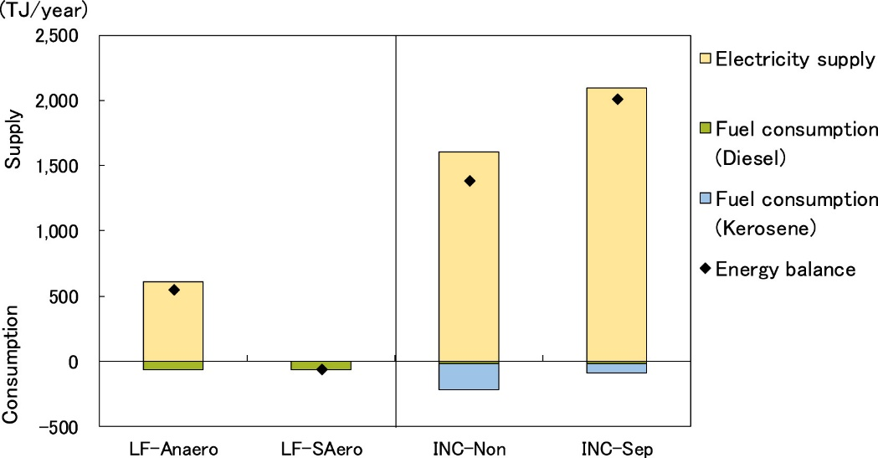
Fig 1 Estimated energy balance results under the one-year condition.

Table 1 Proximate analysis and ultimate analysis of the tannery sludge
Industrial analysis (%) |  |  |  |  | Elemental analysis (%)
Moisture | Ash | Volatile matter | Fixed carbon | LHV  kJ/kg | C | H | N | S
73.25 | 13.11 | 13.61 | 0.03 | 5346.2 | 16.591 | 2.898 | 2.343 | 0.623
Elemental analysis of heavy metal (mg/kg) |  |  | Zn | Pb | Cd | Cu | Mn | Cr
 |  |  | 380 | 280 | 3 | 70 | 500 | 20490

